SeeSaw User Guide
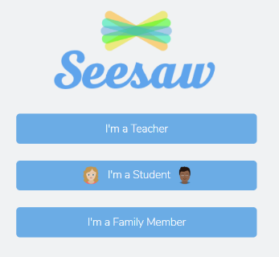
Welcome to Seesaw. We hope you find the following notes useful to get started with your home learning.
Log-In
To access Seesaw, go to the following link.
https://app.seesaw.me/#/login
The following screen will appear. Select ‘I’m a Student’.
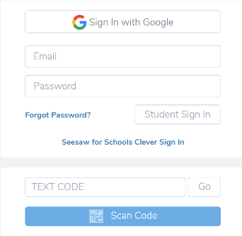
You will be prompted to enter your child’s unique text code. If you do not have this, please contact your child’s class teacher.
In the ‘Text Code’ box, enter the 12 digit code and select ‘GO’. Alternatively, if your device has a camera enabled, scan the QR code provided.

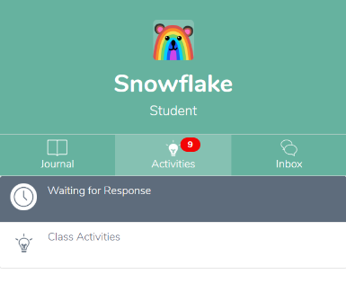
Home Screen
You will now be taken to your child’s home screen.
On the right-hand side of the screen, you will see three navigation bars; Journal, Activities and Inbox.
Journal
A record of your child’s submitted work will can be viewed and accessed on the Journal tab. Children are able to add Photos, Videos, Notes, Links and Upload documents and files from their devices/computers.
Inbox
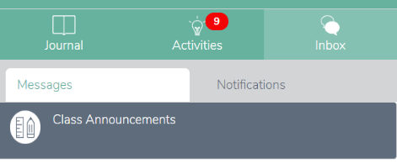
Class teachers can add messages to the Class Announcements section. These may be text, photos or videos. Class and whole school assemblies will be uploaded here on a regular basis so keep checking in for new messages.

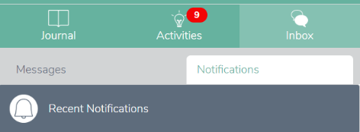
The Notifications tab will display all recent notifications on your child’s Seesaw account, including any response and feedback to submitted work.
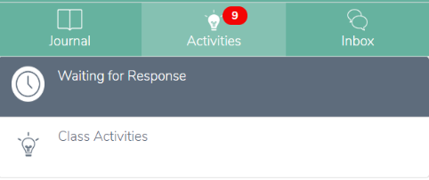
Activities
Class teachers will post activities and learning for your child to complete to the Activities section of the app.
To view the activities, click ‘Activities’ on the navigation tab. Activities will be displayed on the left hand side of the screen.
All activities posted to date will be displayed by clicking on Class Activities. Activities not yet completed will be displayed by clicking on Waiting for Response.
To view the activity, simply click on the chosen activity on the left hand side of the screen. A small pop up box will show a thumbnail of the activity alongside a instructions for what to do.
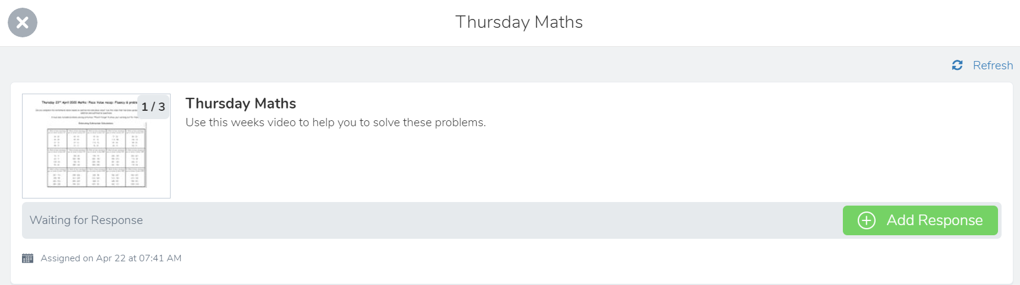
To view the document, click on the image. Use the left and right arrows to scroll across pages. Alternatively, select View Original to open the original copy of the document in PDF format.
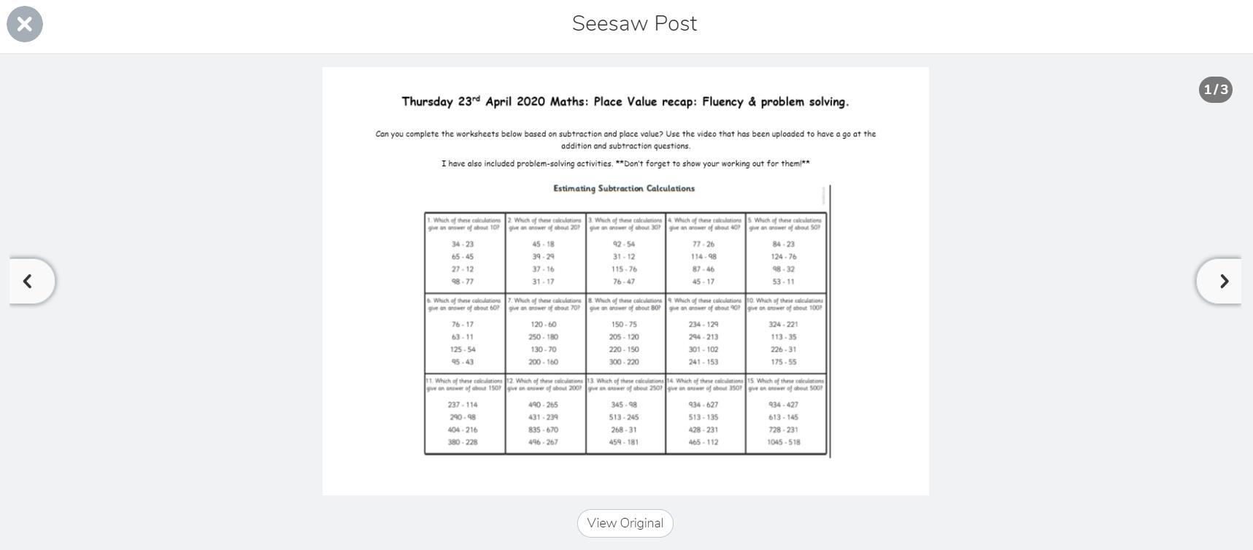
If you prefer to have a printed copy of the activity to work from, select View Original. You will be able to print from the PDF document in the normal way.

Completing Activities
Children can complete activities assigned to them in the following ways.
1. Add Response
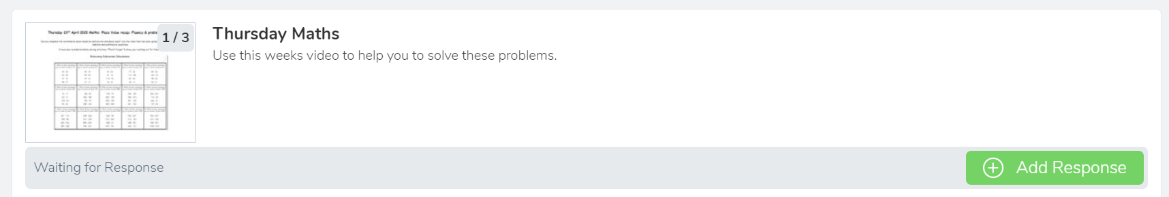
Select the activity you would like to complete and click on Add Response at the bottom right corner.
The activity will open in a new window like below. From here you are able to add drawing, text, voice recordings and photos to the document as well as navigate through each page and view instructions.
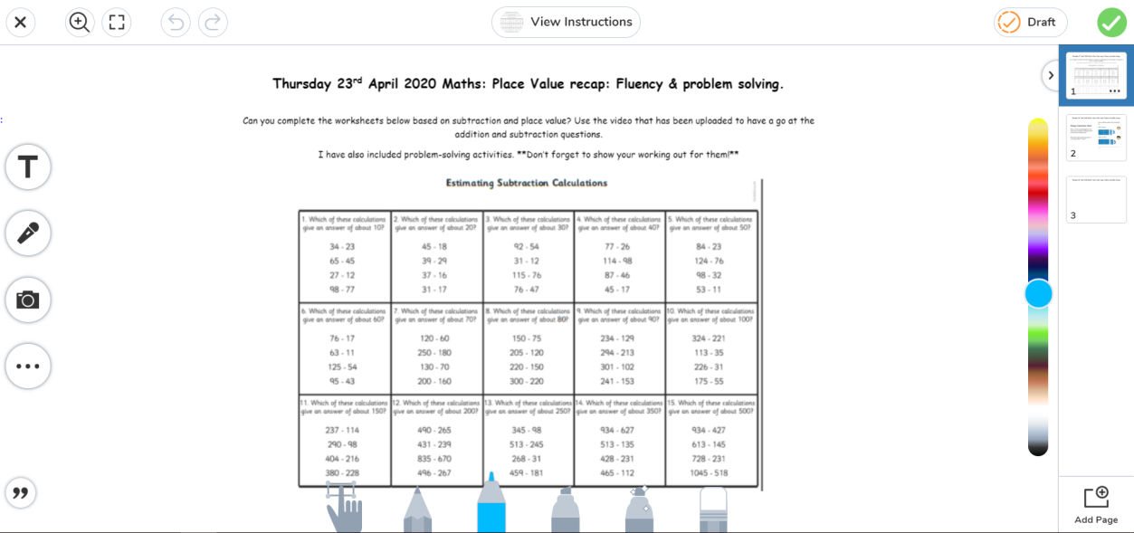
Adds text to the document Adds voice recording Adds photo

For further information on how to draw and edit a document, please refer to video links at the end of this document.
Once you have completed editing your work, select the green tick in the top right hand corner. Alternatively, you can select Save Draft if you would like to complete it at a later time.
Once submitted, your teacher will be able to view the work and respond with any feedback. Only your child’s class teacher is able to view and respond to work submitted. A copy will also appear in your child’s Journal.

2. Adding to Journal

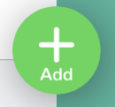
Work can also be submitted through the Journal section of the app. To do this, simply click on the green add button at the top of the screen.
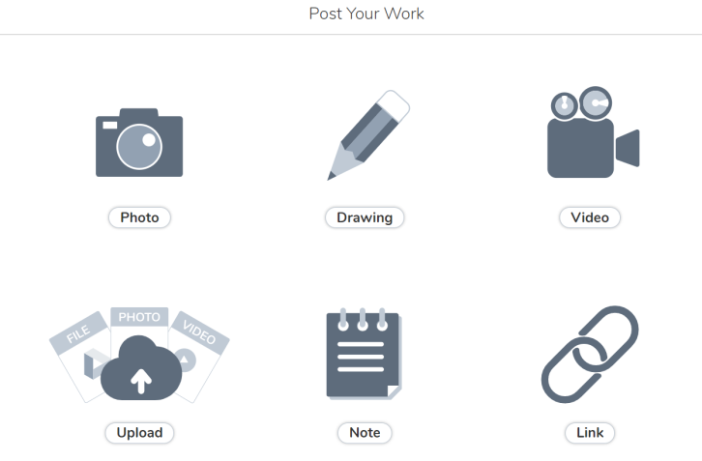
The following page will be displayed.

Some work can be completed on screen using the Photo, Drawing, Video or Note icons. Please refer to the video links at the end of the document for more information on each of these tasks.
If your child prefers to complete learning activities off screen, children can use the exercise book they were provided with at the start of the school closure period. Copies of the work can then be uploaded to your child’s Journal by selecting either the Photo icon or Upload icon shown above.
Once you have selected how you would like to submit work using the icons above, follow the instructions on screen and then select the green tick at the top right hand corner. This will save your work to your Journal ready for the Class Teacher to view and provide feedback. A notification will appear in your inbox once the Class Teacher has provided a response. Only the class teacher will be able to view work submitted by your child.
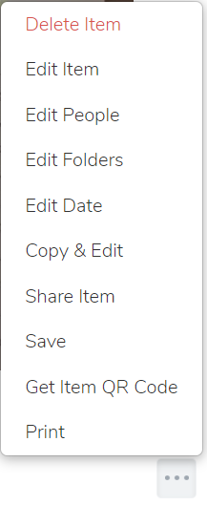
Work uploaded to the journal can be edited, printed and deleted by clicking on the three dots under the work image and selecting the appropriate item.

Signing-Out
You can sign out of your child’s Seesaw account by clicking the named icon at the top left of the screen and selecting Sign out.
Useful Videos
The following videos provide further information about how to add and edit different types of learning to the Seesaw platform in easy step by step tutorials.
How to take a photo
https://www.youtube.com/watch?v=dcURfTn6omQ&feature=youtu.be
How to make a video
https://www.youtube.com/watch?v=LExPEnHyYBQ&feature=youtu.be
How to draw
https://www.youtube.com/watch?v=OXU0j_H7ITA&feature=youtu.be
How to add a note
https://www.youtube.com/watch?v=O9yalwjrxVo&feature=youtu.be
How to upload or link
https://www.youtube.com/watch?v=riAv41WSams&feature=youtu.be

