  Hampshire Primary Behaviour Service has been commissioned by Hampshire and Isle of Wight Partnership of Clinical Commissioning Groups to provide an early intervention service for families, prior to accessing CAMHS support. This will endeavour to provide families with a range of strategies for positive behaviour management and provide a deeper understanding of the reasons behind the behaviour. |  |  | 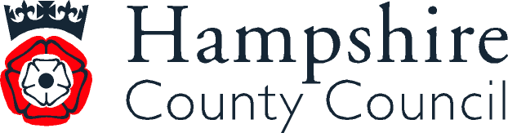  CONTACT US  Basingstoke, Deane & North Test Valley harewood.pbscentre@hants.gov.uk  01256 329206  Fareham & Gosport pbs.lennoxcentre@hants.gov.uk  01329 281890  Havant & East Hants  pbs.robinsoak@hants.gov.uk  02392 572676  New Forest & South Test Valley pbs.cliffordcentre@hants.gov.uk  02380 661777  Rushmoor, Hart & East Hants pbs.thehive@hants.gov.uk  01252 814888  Winchester & Eastleigh pbs.keppelcentre@hants.gov.uk  02380 613152 |  | 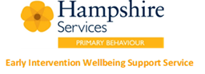  Children and Young People’s SEMH Wellbeing Support Service  
Description of Service  The service provides much needed support for children and young people with Social, Emotional and Mental Health (SEMH) and behavioural needs which can present in a similar way to conditions such as Autistic Spectrum Condition, Attention Deficit Disorder, Attachment Disorder, anxiety and poor emotional wellbeing and who reside in Hampshire.  Children identified as having difficulties such as the above will be referred to the Wellbeing Support Service who will work to identify needs and recommend onward support where appropriate. In addition, the service will be used to provide early intervention for families to support their children who may be presenting with traits of Autism Spectrum Condition before they can be referred for a diagnosis.  By providing early, targeted support through a child-centred approach, the service aims to:  - to enable parents to support their children to self-manage and maintain good emotional wellbeing;  - reduce inappropriate diagnosis;  - enable children to get the most from their education, regardless of the setting;  - promote a healthy home environment and improve family dynamics;  - promote inclusion in schools. |  | How does it work?  A dedicated team of experienced practitioners, provide the following services and support for children living in Hampshire:  - support parents to identify individual needs relating to behaviour and emotional wellbeing;  - hands-on advice and support for families for a wide range of behavioural, emotional and social development needs;  - support for parents/carers, including help with developing a positive home/school relationship, as well as direct work with parents/carers;  - support to families regarding crisis management and conflict resolution;  - support and advice to families during assessment for Education, Health and Care Plans;  - support families to embed strategies that work for their children, so that they can develop self-regulation;  - support families to enable them to meet their child’s individual needs, helping them to develop their strengths, emotional resilience and independence.  Primary Behaviour Service Model  PBS currently operates a model whereby families can access the service through a consultation in the first instance. This enables all who are working closely with the child to explore the causes and symptoms of behaviour and to identify strategies to support, at an early intervention stage.  Through the commissioned funds, GPs, CAMHS or any other Health professional will be able to refer to our early intervention service. This will allow a consultation model to take place with the family and our Parent Support Adviser. This may be followed by the recommendation of a referral to CAMHS if required. |  |  | Referral Pathway

