Botley C of E Primary School
Special Educational Needs Information Report

Botley CofE Primary School serves the village of Botley and beyond and has a Pupil Admission Number of 45. The school is located in a suburban area outside of Southampton. The school community includes children with a wide range of educational, social and emotional needs. At Botley we believe that all learners:
- Are inspired in their learning
- Develop a love and passion for learning
- Are aspirational in what they believe they can achieve
- Develop transferable skills
- Feel confident in themselves and their ability to learn
- Demonstrate positive learning behaviours
- Feel a sense of pride in the learning evidence that they produce (Teaching and Learning Policy)

INCLUSION

At Botley CofE Primary School all children, with or without disabilities or difficulties in learning, have
access to the full curriculum and are educated in a manner that allows them to develop
academically, socially, spiritually and morally. We provide for all children who may come to the
school, including those with Special Educational Needs and disabilities. We subscribe to ‘The Disability Discrimination Act in Schools’ which can be found at https://www.gov.uk/definition-of-disability-under-equality-act-2010 We also welcome our duties under the Equality Act 2010 as a provider of education and recognise that all pupils have the right to achieve highly at our school through praise, celebration, independence and responsibility. This Information Report should be read in conjunction with our Accessibility Plan, which is available on our school website.

This report outlines how we, as a mainstream primary school, aim to support and include your child when additional support is needed. It has been written by our Special Needs Co-ordinator, Mrs Kate Roberts, alongside staff, parents and Governors. If after reading this report you have questions that remain unanswered, please do not hesitate to contact the school. Details of how to do that are at the end of this report.

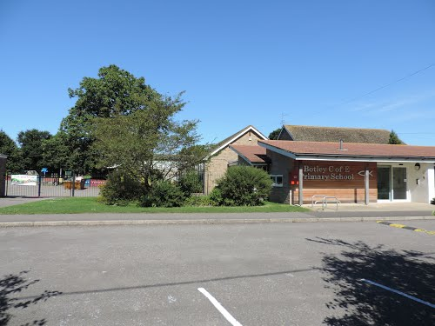


Parents
School

Outside Agencies
Child




THE SEN CODE OF PRACTICE
The 2015 Code of Practice states that:
Children have special educational needs if they have a learning difficulty which calls for special educational provision to be made for them.
Children have a learning difficulty if they:
- have a significantly greater difficulty in learning than the majority of children of the same age;
or
- have a disability which prevents or hinders them from making use of educational facilities of a kind generally provided for children of the same age in schools within the area of the local education authority.
This could be for a variety of reasons such as a physical disability, sensory impairment or emotional problems, as well as learning difficulties.

The guiding principles of the Code of Practice are as follows:
- a child with special educational needs should have their needs met;
- the special educational needs of children will normally be met in mainstream schools or settings;
- the views of the child should be sought and taken into account;
- parents and carers have a vital role to play in supporting their child’s education;
- children with special educational needs should be offered full access to a broad, balanced and relevant education, including an appropriate curriculum for the Foundation Stage and the National Curriculum.

THE LOCAL OFFER
Since September 2014, every Local Authority is required to publish information about services they expect to be available in their area for children and young people from birth to 25 who have special educational needs and/or disabilities (SEND); and also services outside of the area which they expect children and young people from their area will use. This will be known as the ‘Local Offer’.
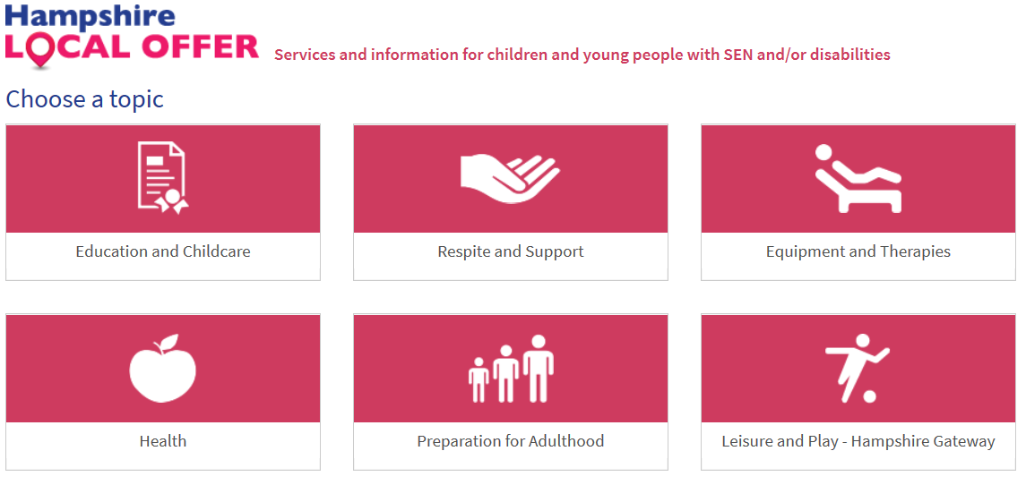
Details can be found at https://fish.hants.gov.uk/kb5/hampshire/directory/localoffer.page
Contact SENDIASS (Special Educational Needs and Disabilities Advice and Support Service) - https://www.hampshiresendiass.co.uk/ for further advice.
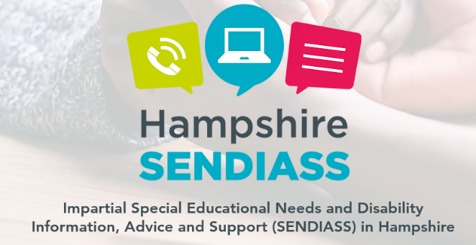

HOW DOES THE SCHOOL KNOW IF CHILDREN NEED EXTRA HELP?
At Botley Primary C of E School children are identified as having SEN through a variety of ways including the following:
- liaison with their previous school / early years provider;
- the child attaining significantly below age expected levels;
- specific SEN assessments and tests, once a concern has been raised;
- concerns raised by a parent;
- concerns raised by a teacher for example behaviour or self-esteem that is affecting performance;
- liaison with external agencies i.e. physio / Occupational Therapist; Educational Psychologist assessments;
- health diagnosis through a paediatrician.


HOW CAN I LET THE SCHOOL KNOW IF I AM CONCERNED ABOUT MY CHILD
If you have any concerns, please talk to us. Firstly, contact your child’s class teacher who will be very happy to talk to you about any concerns or questions that you have. We pride ourselves on building positive relationships with parents. We are open and honest with parents and hope that they are able to be the same with us. Your concerns and questions may then be taken to our Special Needs Co-ordinator (Mrs Kate Roberts) or our Headteacher (Mr Joe Cooil).

HOW WILL BOTLEY COFE PRIMARY SCHOOL SUPPORT MY CHILD?
Class teachers are responsible for the progress and well-being of all children in their class. The SENCo oversees the progress and support for all children with additional needs in the school. There may be a Learning Support Assistant (LSA) working with your child either individually or as part of a group, if this is seen as necessary by the class teacher. The regularity of these sessions will be explained to parents when the support starts.

Your child may be placed on the Special Needs register and, if this is the case, a Pupil Passport will be written for them and specific short term targets. Pupil Passports recognise needs under the Code of Practice headings of:
- Cognition and Learning
- Communication and Interaction
- Social, Emotional and Mental Health
- Sensory and/or Physical
You will be kept informed, given copies of the Pupil Passport and have the opportunity to discuss your child’s targets and progress.

WHO WILL EXPLAIN THIS TO ME?
In the first instance, your child’s class teacher will discuss your child’s Pupil Passport with you, their targets and any additional support that they are receiving. In addition, the SENCo may also meet with you and you can request a meeting with the SENCo at any time.

HOW ARE THE GOVERNORS INVOLVED AND WHAT ARE THEIR RESPONSIBILITIES?
Governors are regularly kept informed through both meetings and the work they do in school:
- the SENCO and Head Teacher report to the Governors every term to inform them about the progress of children with SEND – this report does not refer to individual children and confidentiality is maintained at all times;
- one of the Governors is responsible for SEN and meets with the SENCO. They also report to the Governors to keep all informed;
- the Governors agree priorities for spending within the SEN budget with the overall aim that all children receive the support they need in order to make progress.

HOW WILL THE CURRICULUM BE MATCHED TO MY CHILD’S NEEDS?
All work within class is pitched at an appropriate, differentiated level so that all children are able to access their learning according to their specific needs. This may be through the type of task or the use of additional or specialist resources. If applicable, a trained Learning Support Assistant (LSA) may work with a child 1:1 or in a small group to focus on and target specific curriculum needs.
Some pupils will require 1:1 support on skills outside of their year group curriculum. This may be for a regular timetabled session each day and will be delivered by the class teacher or a specialist LSA.
INCREASED AMOUNT OF ADULT SUPPORT

Teacher or LSA led group focusing on a key skill, in addition to normal curriculum work. This will be usually a couple of times a week.

Receiving targeted teaching in class either with teacher or with an LSA (who is guided by the teacher). The activity may be adapted depending upon need.

If a child has very specific or significant needs, the curriculum will be modified to suit their needs.
*Your child’s progress is reviewed regularly with their class teacher, a member of the SLT and the SENCo, where appropriate.
* If a child requires a significant amount of additional support an Education Health Care Plan (EHCP) may be considered. These additional, formal procedures are used only where a child requires significant support which is often of a more complex nature. The process formally documents the specific needs and targeted support for a child. A review meeting takes place once a year, with a written report summarising the issues discussed. Copies of this report are shared with parents, supporting agencies and the Local Authority.

HOW WILL I KNOW ABOUT MY CHILD’S PROGRESS AND HOW WILL YOU HELP ME TO SUPPORT MY CHILD’S LEARNING?
• We offer an open-door policy where you are welcome to make an appointment at an appropriate time to meet with either the class teacher or SENCo and discuss how your child is getting on. We can offer advice and practical ways that you can help your child at home.
• We may operate a home / school link book for certain children which will be sent home regularly so that comments from parents and teacher can be shared and responded to when needed.
• If your child is on the SEN register, they will have a Pupil Passport (PP) which will have individual / group targets. This is discussed on a termly basis and parents are given a copy of the PP. The targets set are SMART (Specific, Measurable, Achievable, Realistic, Time scaled) targets with the expectation that the child will achieve the target by the time it is reviewed.
• If your child has complex SEND they may have an EHCP, which means that a formal meeting will take place to discuss your child’s progress. A report will be written after that meeting.

HOW WILL THE SCHOOL HELP ME SUPPORT MY CHILD AT HOME?
It is important for you to be kept fully involved with your child’s learning:
- Each child will have a Pupil Passport. When discussing this with you, your child’s class teacher will outline what your child is doing in school and give suggestions for support at home.
- The class teacher will be very happy to suggest ideas for parents to try with their child.
- The class teacher will meet with parents at least on a termly basis (this will usually be as part of Parent’s Evening) to discuss their child’s needs, support and progress;
- For further information, the SENCO is available to discuss support in more detail and is available for appointments at any time.

HOW DOES THE SCHOOL KNOW HOW WELL MY CHILD IS DOING? HOW WILL THEY KNOW IF ADDITIONAL SUPPORT HAS HAD A POSITIVE IMPACT?
• As a school we measure your child’s progress in learning against National expectations and age related expectations.
• The class teacher continually assesses your child and notes areas where they are improving and where further support is needed. As a school, we track children’s progress from entry at Reception through to Year 6, using a variety of different methods including National Curriculum levels and Reading and Spelling ages.
• Children who are not making expected progress are picked up through Pupil Performance meetings with the Class teacher and Deputy or Head Teacher. In this meeting, a discussion takes place outlining why individual children are experiencing difficulty and what further support can be given to aid their progression. The SENCo will also be consulted for advice. If your child receives additional support as a result of Pupil Performance meetings, this will be discussed with you at the following Parents Evening or at an additional meeting.
• When the child’s additional support is reviewed, comments are made against each target to show what progress the child has made. If the child has not met the target, the reasons for this will be discussed, then the target may be adapted into smaller steps, or a different approach may be tried to ensure the child does make progress.
Please note that children may move off the SEN register when they have ‘caught up’ or made sufficient progress so that their difficulties are no longer significant. For children who need additional support in the area of, for example, Social, Emotional and Mental Health, their progress may not be measured by academic data. For these children we may look to see if they have increased self-esteem and confidence in their own abilities and are happier in school.

WHAT SUPPORT WILL THERE BE FOR MY CHILD’S OVERALL WELL BEING?
WHAT IS THE PASTORAL, MEDICAL AND SOCIAL SUPPORT AVAILABLE IN THE SCHOOL
• We are an inclusive school; we welcome and celebrate diversity. All staff believe that children’s self-esteem is crucial to their well-being. We have a caring, understanding team looking after our children.
• The class teacher has overall responsibility for the pastoral, medical and social care of every child in their class; therefore this would be the parents’ first point of contact. If further support is required, the class teacher liaises with the SENCo for further advice and support. This may involve working alongside outside agencies such as Health and Social Services, and/or the Behaviour Support Team.
• The school has an ELSA (Emotional Literacy Support Assistant) who works under the direction of the SENCo, supporting vulnerable children.
• The school has a policy regarding the administration and managing of medicines on the school site. (available to read on the School Website or a copy is available from the School Office)
• Parents need to contact the class teacher if medication is recommended by Health Professionals to be taken during the school day.
• On a day to day basis trained members of staff oversee the administration of any medicines.
• As a staff we have regular training and updates on conditions and medication affecting individual children, such as Epipen training, so that all staff are able to manage medical situations.
*As a school we have a very positive approach to all types of behaviour with a clear behaviour system that is followed by all staff and pupils. (see school Behaviour Policy on the School Website or a copy is available from the School Office)
• If a child has significant behavioural difficulties, an Individual Behaviour Management Plan (IBMP) is written alongside the child and parents to identify the specific issues, put relevant support in place and set targets. If necessary, a referral will be made to the Primary Behaviour Support Team, who provide additional help, support and advice.
• After any behaviour incident, we expect the child to reflect on their behaviour with an adult. This helps to identify why the incident happened and what the child needs to do differently next time to change and improve their behaviour.
• Attendance of every child is monitored on a daily basis by the Admin department. Lateness and absence are recorded and reported upon to the Head Teacher. Support is given through an incentive scheme, where good attendance is actively encouraged throughout the school. The Head Teacher will also meet with the parents of any child with persistent absence or lateness to plan support.

HOW WILL MY CHILD BE ABLE TO CONTRIBUTE THEIR VIEWS?
- Children who have additional interventions discuss the adult as they work on them and are able to discuss how they feel they are progressing.
- We use annual pupil questionnaires to actively seek the viewpoints of children in areas, for example safety, behaviour and the curriculum.
- If your child has an EHCP, their views will be sought before any review meetings.
- Our School Council hold fortnightly Class Meetings where all children are actively encouraged to share their views about key areas of school development. The aim of these meetings is to give each pupil a voice in school development.

WHAT SPECIALIST SERVICES AND EXPERTISE ARE AVAILABLE AT OR ACCESSED BY THE SCHOOL?
As a school we work closely with any external agencies that we feel are relevant to individual children’s needs within our school including: Advisory Teachers, Behaviour Intervention, Health including – GPs, school nurse, CAMHS, clinical psychologist, paediatricians, speech & language therapists, physiotherapists, occupational therapists; social services including Locality Teams, social workers and Educational Psychologists, Children’s Centres.

HOW ARE STAFF IN SCHOOL HELPED TO WORK WITH CHILDREN WITH SEND AND WHAT TRAINING DO THEY HAVE?
- We have a member of staff trained as an ELSA who receives regular support from the Educational Psychologist.
- Another member of staff has had training in delivering Speech & Language programmes from Speech & Language therapists and has cascaded her training to our other LSAs.
- Another member of staff has had training in delivering Physio and OT programmes from our external Physiotherapist and the Occupational Therapist.
- All of our LSAs have had training in delivering a variety of numeracy, reading, spelling and phonics programmes.
- Our SENCo attends training within our school and cluster and at County level to ensure that she is up to date with developments and good practice in SEN.
- The SEN Governor receives Governor training to support the role.
- The SENCo has the masters level National Award for Special Educational Needs Co-ordiantors

HOW WILL MY CHILD BE INCLUDED IN ACTIVITIES OUTSIDE THE CLASSROOM INCLUDING SCHOOL TRIPS?

• All children are included in all parts of the school curriculum and we aim for all children to be included on school trips wherever practicable. We will provide the necessary support to ensure that this is successful.
This Photo by Unknown Author is licensed under CC BY
• A risk assessment is carried out prior to any off-site activity to ensure everyone’s health & safety will not be compromised. In the unlikely event that it is considered unsafe for a child to take part in an activity, then alternative activities which will cover the same curriculum areas will be provided in school.

HOW ACCESSIBLE IS THE SCHOOL ENVIRONMENT?
• The school site is wheelchair accessible with a disabled toilet large enough to accommodate changing. The school is all on one level with ramps at specified fire exits.
• We liaise with EMTAS (Ethnic Minority Achievement Service) who assist us in supporting our families with English as an additional language.
*For pupils who require additional resources or equipment to access the curriculum we seek advice from and work closely with the relevant outside agencies. We train staff in the use of these resources and carry out the necessary risk assessments for these pupils.
* We have an Accessibility Plan in place and, where feasible, make reasonable adjustments to improve the accessibility of the environment to meet individual needs. Our policy and practice adheres to the Equality Act of 2010.

HOW WILL THE SCHOOL PREPARE AND SUPPORT MY CHILD WHEN JOINING BOTLEY C of E PRIMARY SCHOOL OR TRANSFERING TO A NEW CLASS OR SCHOOL?
• We encourage all new children to visit the school prior to starting, when they will meet their buddy and be shown around the school. For children with SEND we would encourage further visits to assist with the acclimatisation to new surroundings. Where practicable, we would also visit them in their current school.
• We write social stories with children if transition will potentially be difficult.
• When children are preparing to leave us for a new school, typically to go to Secondary education, we arrange additional visits. At our ‘feeder’ secondary school, Deer Park, they run a programme specifically tailored to aid transition for more vulnerable pupils.
• We liaise closely with staff when receiving and transferring children to different schools ensuring all relevant paperwork is passed on and all needs are discussed and understood.
• If your child has complex needs then we will invite staff from their new school to attend a transition meeting.

HOW ARE THE SCHOOL’S RESOURCES ALLOCATED AND MATCHED TO CHILDREN’S SEND NEEDS?
• We ensure that all children who have Special Educational Needs or disabilities are met to the best of the school’s ability with the funds available.
• We have a team of LSAs who are funded from the SEN budget who deliver programmes designed to meet groups of children’s needs.
• The budget is allocated on a needs basis. The children who have the most complex needs are given the most support, often involving an LSA.
• Resources in school to support pupils with SEND reflect the range of need and include ICT software, specialist behavioural programs, assessment tools, physical resources such as specialist seating and speech and language programs.

HOW IS THE DECISION MADE ABOUT HOW MUCH SUPPORT MY CHILD WILL RECEIVE?
• The SENCo, class teacher and other adults who work with your child in school will discuss your child’s needs and what support would be appropriate.
• Different children will require different levels of support in order to bridge the gap to achieve age expected levels or their own personal targets, as outlined in the section
•Support will be adapted and changed in light of assessments of your child’s needs and may increase, alter or decrease as they progress in particular areas of need.


This Photo by Unknown Author is licensed under CC BY-NC-ND

Here is a glossary of some of the abbreviations used in Special Educational Needs – we know they can be a bit confusing!
Abbreviation
ADD | Attention Deficit Disorder
ADHD | Attention Deficit and Hyperactivity Disorder
ASD/ASC | Autistic Spectrum Disorder/Condition
BESD | Behavioural, Emotional and Social Difficulty
CAMHS | Child and Adolescent Mental Health Service
COP | SEN Code of Practice
CP | Child Protection
CS | Children’s Services( Social Services)
DST | Dyslexic Screening Test
EAL | English as an Additional Language
EHCP | Educational &Health Care Plan
EIS | Educational Inclusion Service
EMTAS | Ethnic Minority Traveller Achievement Service
EP | Educational Psychologist
FSM | Free School Meals
HI | Hearing Impairment
IBMP | Individual Behaviour Management Plan
IEP | Individual Education Plan
KS | Key Stage
LAC | Looked After Child(Local Authority)
LEA | Local Education Authority
MLD | Moderate Learning Difficulty
MSI | Multi-Sensory Impairment
NC | National Curriculum
OT | Occupational Therapist
PBS | Primary Behaviour Support
PD | Physical Disability
PDA | Pathological Demand Avoidance
PMLD | Profound and Multiple Learning Difficulties
PP | Pupil Premium
PSA | Parent Support Advisor
SALT | Speech and Language Therapist
SCD | Social Communication Disorder
SEND | Special Educational Needs and Disability
SENCo | Special Educational Needs Co-ordinator
SLCN | Speech, Language & Communication Needs
SLD | Severe Difficulties Learning
STA | Specialist Teacher Advisor
SpLD | Specific Learning Difficulty ( Dyslexia/Dyscalculia etc)
VI | Visual Impairment
YC | Young Carer

