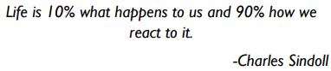
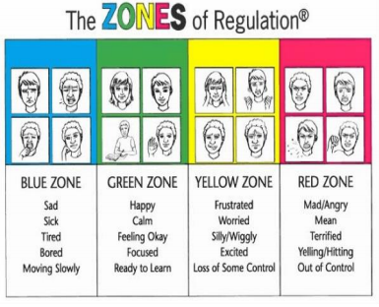
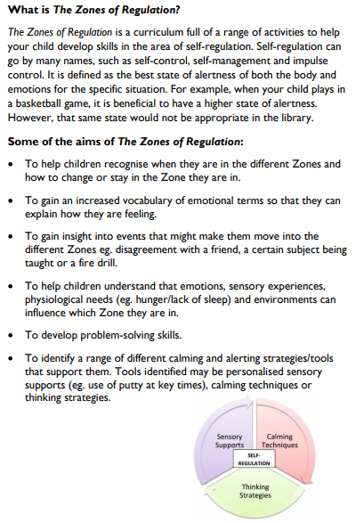
A guide to The Zones of Regulation
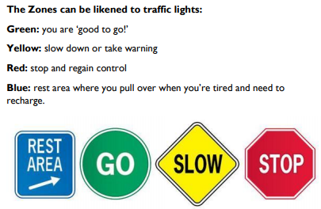
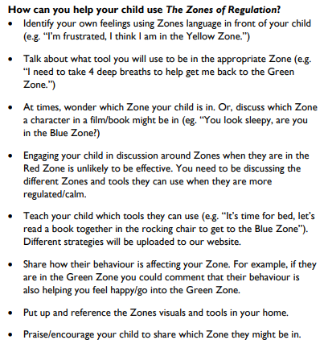

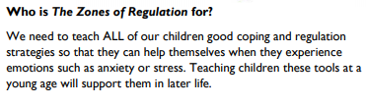
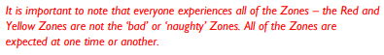
How can I find out more about the Zones?
www.zonesofregulation.com
www.weareteachers.com/zones-of-regulation-activities
www.theottoolbox.com
www.pinterest.co.uk
How will my child learn about the Zones of Regulation?
We will be introducing the Zones through discrete teaching lessons and through our PSHE curriculum. We will also be using the Zones language as part of daily school life.
Some children prefer not to use the ‘Zones language’ but label the emotions directly – this is fine and encouraged!

