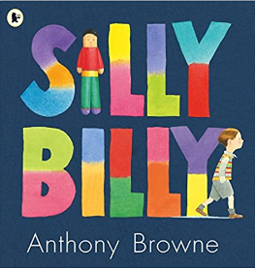
Story time

Silly Billy by Anthony Browne
Billy is a bit of a worrier. He worries about hats and shoes. He worries about clouds and rain and giant birds. Most of all he worries about staying at other people's houses. His mum and dad try to help, but still Billy worries ... until a visit to his grandma's shows him how to overcome his fears with the aid of his imagination – and some tiny worry dolls.

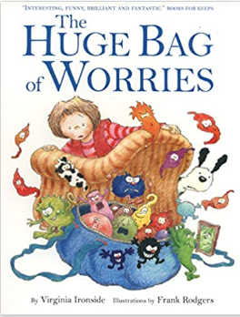

The Huge Bag of Worries by Virginia Ironside
Wherever Jenny goes, her worries follow her - in a big blue bag. They are with her all the time - at school, at home, when she is watching TV and even in the bathroom! Jenny decides they have to go, but who will help her get rid of them?
A funny and reassuring look at dealing with worries and anxiety, to be used as a spring board into important conversations with your child.

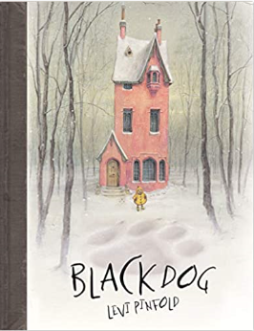

Black Dog by Levi Pinfold
Only Small, the youngest of the Hopes, has the courage to face the Black Dog that appears outside the family's home. When it chases her through the forest she shows no fear, so it grows smaller and smaller.

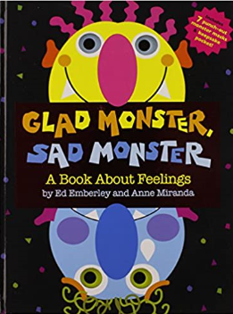
Glad Monster, Sad Monster by Ed Emberley
Glad, sad, silly, mad - monsters have all kinds of different feelings! In this innovative die-cut book, featuring a snazzy foil cover, you'll try on funny masks as you walk through the wide range of moods all little monsters (and kids!) experience. Here's a fun, interactive way to explore the many different ways we feel! Caldecott Medal-winning author/artist Ed Emberley provides readers with an imaginatively crafted book that helps children identify and understand their emotions.

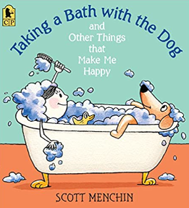
Taking a Bath with the Dog by Scott Menchin
What do you do when it seems as if nothing will make you happy? For one little girl, it's a good time to take a survey, from subjects including a quick little rabbit (running around in a wheel) and a snazzy centipede (shoes, lots of shoes). Scott Menchin's amusing story and his whimsical characters show us that doing what we love best can bring the biggest smiles of all.

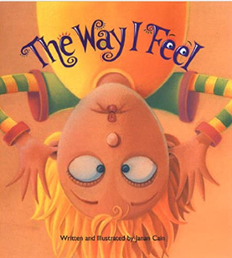

The Way I Feel by Janan Cain
Feelings are neither good nor bad, they simply are. Kids need words to name their feelings, just as they need words to name all things in their world. The Way I Feel uses strong, colorful, and expressive images which go along with simple verses to help children connect the word and the emotion. Your child will learn useful words, and you will have many chances to open conversations about what's going on in her/his life.
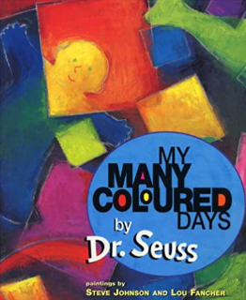

My Many Coloured Days by Dr Seuss
'You'd be surprised how many ways I change on different coloured days .'Maybe on some days you feel sort of brown, like a bear; you feel slow and low, low down. But then comes a yellow day and wheeeeeeeee! you feel like a busy, buzzy bee. Dr. Seuss takes the reader on a journey through many different moods in this vibrant and highly original book.

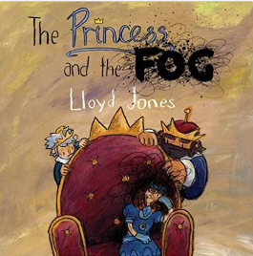
The Princess and the Fog by Lloyd Jones
Once upon a time there was a Princess. She had everything a little girl could ever want, and she was happy. That is, until the fog came... The Princess and the Fog is picture book to help sufferers of depression aged 5-7 cope with their difficult feelings. It uses vibrant illustrations, a sense of humour and metaphor to create a relatable, enjoyable story that describes the symptoms of childhood depression while also providing hope that things can get better with a little help and support.

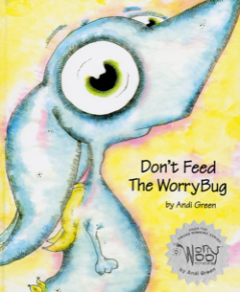
Don’t Feed the WorryBug by Andi Green
In this whimsical rhyming book, Wince, the monster of worries, learns that the more he worries, the more the pesky WorryBug grows. Eventually the WorryBug grows so big that it can’t be ignored, and Wince knows he needs to do something. The book does a good job of illustrating how anxiety can become overwhelming and teaches kids how they can take charge of their anxiety.

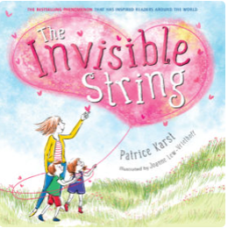

The Invisible String by Patrice Karst
This bestselling picture book introduces little ones to the concept of an invisible link between people, even when they’re separated. In the story, a mom explains to her children that there is a “very special string made of love” that connects them to everyone they love. “When you’re at school and you miss me, your love travels all the way along the string until I feel a tug on my heart,” Karst writes. The story continues with explaining how far the string reaches — to a submarine captain in the ocean, a dancer in France, and even to a beloved relative in heaven.
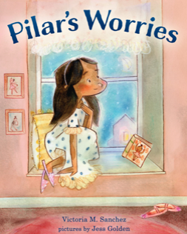
Pilar’s Worries by Victoria Sanchez
In this picture book, Pilar lives and breathes ballet — she even does pliés while brushing her teeth. But auditioning for the winter ballet performance makes her feel scared, and she almost doesn’t go. By using smart coping techniques, like positive thinking and talking with her friends, she’s able to overcome her fears.

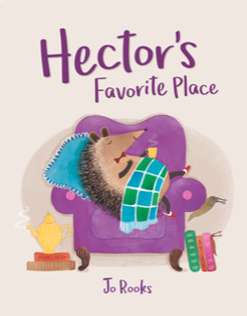
Hector’s Favourite Place by Jo Rooks
A cute hedgehog turns down ice-skating and playing in the snow with his animal friends because of his worries. “What if he had forgotten how to skate? He could fall and hurt himself.” When Hector receives a fun invitation to the Winter Forest Party, he hesitates for a while, and then realizes that he has to be brave. “It’s an adorable story,” says an expert at the Child Mind Institute. “I like that Hector does a little more, and then a little more, and so on.”

