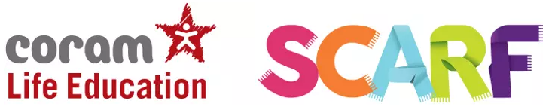
We use a PSHE scheme from Coram Life Education called SCARF across the whole school. This supports positive behaviour, mental health, wellbeing, resilience and achievement.
As part of our subscription to Coram, we have access to a full PSHE curriculum that also meets the requirements of the Relationships, Health and Sex Education curriculum. This gives teachers access to suggested planning, resources, schemes of work and additional resources. We also have a yearly visit from The Life Bus, where staff from SCARF come to work with every class and deliver part of the PSHE curriculum. In addition, we have the support of Coram with other resources that we can use to measure and build wellbeing.
Also, there is a link for parents to access PSHE home learning for children. The link is:
http://www.coramlifeeducation.org.uk/scarf/home-learning-unit-1
Here is what some of our children think of PSHE at Botley School:
You learn to say what you think, but you have to think about whether it is kind to say it.
We play games that help us learn.
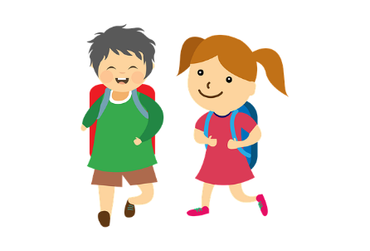
It’s when we think (sharing our opinions) and we talk about things like bullying
It teaches you about right and wrong choices
It’s about who your character is – you can’t be someone you’re not. We are all individual.
We learn about keeping safe online and road safety – these help me in my everyday life to keep safe.
.

