Books to support reading for vulnerable pupils
We have purchased phonic reading books to support our fragile learners with reading, supporting their understanding of phonics in a structured way. These books are used in school when children read 1:1 with adults.
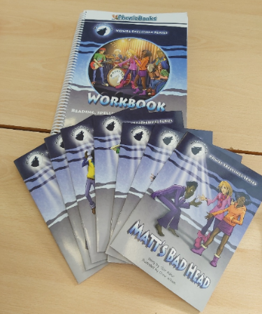
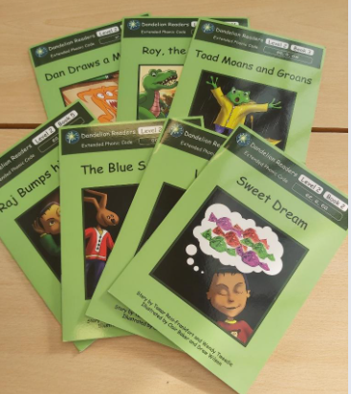

We have also purchased additional reading books from Barrington Stoke, which are structured and designed in such a way that they are supportive for readers with dyslexia. Their layout stops pages from being too overcrowded, stories are edited to ensure unnecessary words don’t hinder comprehension and they are written by well-known authors to encourage a love of reading. These books are used in school for children when they read 1:1 with adults. More information on Barrington Stoke books can be found at https://www.barringtonstoke.co.uk/


