
BOTLEY C of E PRIMARY SCHOOL
ANTI-BULLYING INFORMAITON LEAFLET
FOR PARENTS AND CHILDREN

WHAT IS BULLYING?
Bullying is:
- Deliberately hurtful behaviour.
- Repeated over a period of time.
- Difficult for those being bullied to defend themselves.
We use the acronym STOP to remind ourselves what bullying is….

Several
Times
On
Purpose
One off or short term incidents of poor, aggressive, argumentative or abusive behaviour do not constitute bullying. These will, of course, be dealt with in school but they will not be dealt with as an incident of bullying.

There are four main types of bullying:-
Physical – hitting, kicking, taking belongings
Verbal – name-calling, insulting, racist remarks
Indirect – spreading hurtful rumours about someone, excluding someone from
social groups or activities
Electronic – known as “cyber bullying”; for example via mobile phones, text
messages, phone calls and computers (e.g. e-mails, websites,
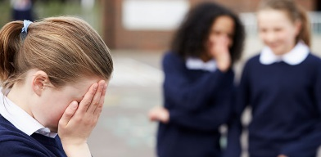
apps, chatrooms)

WHY IS IT IMPORTANT TO STOP BULLYING?
It is important to stop bullying because: -
- Bullying makes people unhappy.
- Children who are being bullied find it difficult to concentrate fully on their learning.
- Some children may not want to come to school to avoid being bullied.
- All children should see school as a safe, secure environment that they look forward to going into every day
- Children who see bullying behaviour are likely to copy this anti-social behaviour
- Bullying can ‘force’ children into activities that they are uncomfortable with, including those which could be classed as ‘radicalisation’.
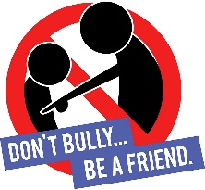
WHAT DO I DO IF I AM BEING BULLIED?
Do …….. Don’t ……
TELL SOMEONE Do what the bully says
Ask them to STOP if you can Get angry and hit or fight back
Use eye contact and tell them to go away Hide what is happening
Ignore them and walk away Think it’s your fault
Remember it is not your fault

WHAT CAN I DO IF MY CHILD IS BEING BULLIED?
If you feel that your child is being bullied, please talk to their class teacher in the first instance. If you would like further advice, discussion or support after this, please talk to your child’s Year Leader or Miss Sambles, the Deputy and SENCo.
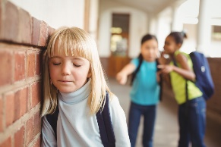
WHAT WILL THE SCHOOL DO IF MY CHILD IS BEING BULLIED?
- Teachers will respond calmly and consistently to incidents of bullying. They will share the expected standard of behaviour with the person who has done the bullying, and they will be encouraged to behave in a more acceptable way.
- If the situation does not improve, the teacher will meet the victim again and find out what has happened.
- A meeting will then be set up with everyone involved including the bullied child, the bully and bystanders. They are told how the victim is feeling.
- Each child is asked how the behaviour has affected the victim.
- The group is given the responsibility to sort the situation out with adult support.
- Each child suggests a way in which they will change their own behaviour in the future.
- After about a week each member of the group is seen individually to review the situation
Bullying will not be tolerated or accepted at Botley C of E Primary School. If it occurs it will be dealt with robustly and effectively.

WHERE ELSE CAN I GET SUPPORT AND ADVICE?
https://www.bullying.co.uk/
https://www.kidscape.org.uk/advice/advice-for-parents-and-carers/
https://www.anti-bullyingalliance.org.uk/tools-information/advice-parents
https://www.nspcc.org.uk/what-is-child-abuse/types-of-abuse/bullying-and-cyberbullying/

