2nd November 2020
Dear Parents,

RE: NSPCC’s Speak out. Stay safe. online programme

I am pleased to tell you that this half term we will be participating in the NSPCC’s Speak out. Stay safe. online programme. This consists of an online assembly and supporting classroom based activities. Speak out. Stay safe. is a safeguarding programme available to all primary schools in the UK and Channel Islands. It aims to help children understand abuse in all its forms and to recognise the signs of abuse in a child friendly, interactive way. Children are taught to speak out if they are worried, either to a trusted adult or Childline.

The NSPCC have developed an online version of their Speak out. Stay safe. programme to help overcome some of the challenges that the Coronavirus (COVID-19) pandemic has presented in relation to having external speakers in school. In the online assembly, the Speak out. Stay safe. messages continue to be delivered in a fun and interactive way with the help of their mascot Buddy as well as special guest appearances from Ant and Dec.

We have studied the content of the materials and are extremely confident that they are appropriate for primary-school-aged children. By the end of the programme, we’re convinced children will feel empowered – knowing how they can speak out and stay safe. If you would like to know more about the Speak out. Stay safe. programme you can find more information on the NSPCC website www.nspcc.org.uk/speakout or you can contact your child’s class teacher.

Talking PANTS with your children
The NSPCC’s work in schools will help encourage conversations about staying safe and they have a number of child-friendly materials to help you carry on the conversation afterwards. That includes ‘Talk PANTS’, a simple way for parents to help keep children safe from sexual abuse without using scary words or ideas. The guide uses the rules of PANTS to teach children that their body belongs to them and them alone. You can find out more and download the free resources at www.nspcc.org.uk/pants.

Childline Under 12’s Website
Childline also have a website with age appropriate advice for primary school children on topics such as bullying. It also has games and other interactive tools. Your child can visit it at www.childline.org.uk/kids.
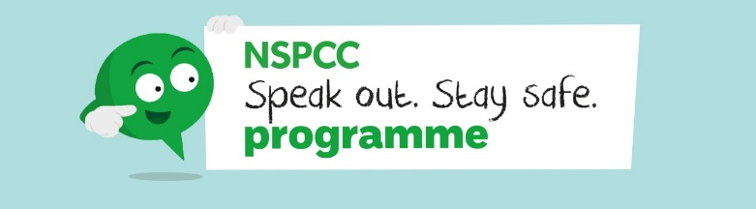
Yours Sincerely,


Miss C. Sambles
Deputy Head/SENCo

